EOC #7: Lab Equipment
For the following pieces of lab equipment
Crucible
Evaporating dish
Thermometer
Scale
Beaker
Volumetric flask
Graduated cylinder
ruler

Draw a picture of the piece of equipment
Give a brief description of its specific use in the lab
Give units the equipment measures, if applicable

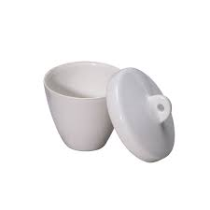
Example:
Crucible: used to heat solids when extremely
high temperatures are needed.

Here is a description of each:
Evaporating dish: used to separate the solid from the liquid in a solution. The solution is heated, thus the liquid “evaporates” and solid is left in dish

Thermometer: used to measure temperature of a sample units: ºC

Scale: used to measure the mass of a sample units: grams

Beaker: used to hold liquids, not to measure them

Volumetric flask: used to make a very precise concentration of a solution. units: mL or Liters

Graduated cylinder: used to measure volume of liquids units: mL or liters
Ruler: used to measure volume of a cube units: cm³

