EOC Concept Notebook
Purpose and Grading
- Create an ongoing comprehensive study guide for the EOC standards
- Directions will be followed explicitly, to that end, the grade will be all or nothing.
- Due: the day of the unit test to which they were assigned
- Mandatory: If not turned in the day of the unit exam, or turned in incomplete, a zero grade will be given; however you will still be require to come in during directed study time to complete

Explicit Instruction:
- Top of first page will be titled: Unit ____ EOC concepts
- You will start on left side of paper with number and concept, sufficient space will be left between concept and discussion of concept, then discussion of concept
- You will be asked define, compare, calculate, summarize different standards. Here are direction for how to correctly complete those standards:
- Examples and non-examples must contain a brief justification or explanation of why your example follows the definition and non-example does not follow definition.
- Summaries must be put in chart or separate columns with headings
- If math involved, show how the math is done (self-tutorial)
- Comparisons: bulleted side by side
- Particulate level drawing: accurately depict size, motion, arrangement of applicable particles.
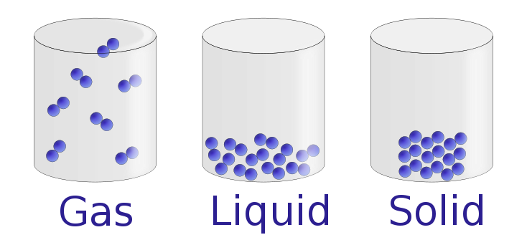
This would show, at the particulate level, the difference in arrangement of molecules in the solid, liquid, and gaseous state

