EOC Concepts Unit 3
Remember to start on right hand side
- Periodic table: sketch a periodic table and show the general areas of metals, metalloids, and nonmetals
- Trends: sketch a periodic table and draw the arrow of increase for the following trends: ionization energy, electron affinity, electronegativity, and atomic size
- Ionization energy: define, write equation for, and state what type of ion is formed (anion or cation)
- Electron affinity: define, write equation for, and state what type of ion is formed (anion or cation)
- Metals: state general properties of ionization energy and electron affinity
- Non metals: state general properties of ionization energy and electron affinity
- Heating curve of water: sketch this chart for the phase changes of water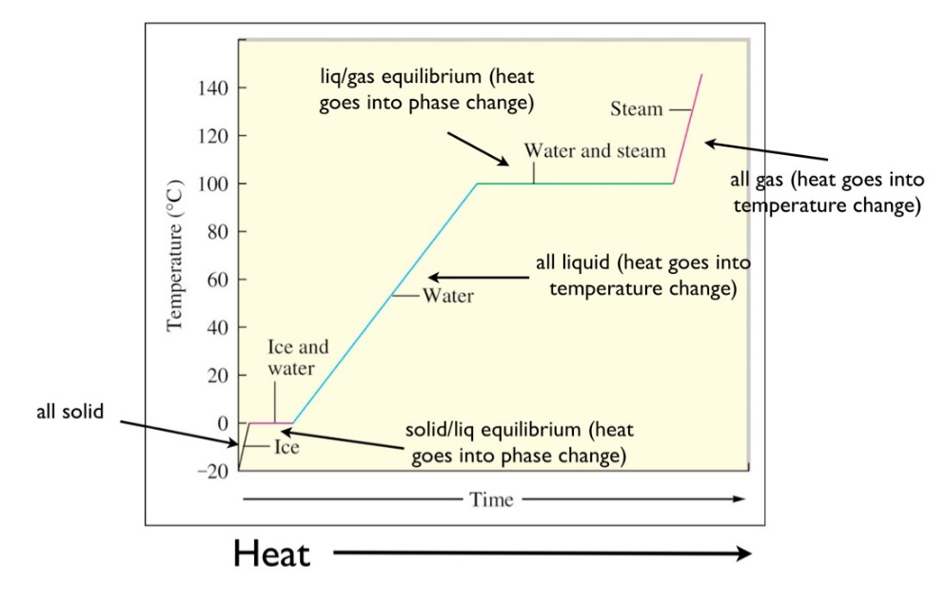
- Phase changes: list all SIX phases changes and state what is happening in each (ex: melting: solid→liquid)
- Energy calculation: q=mcΔt state which each variable stands for in the given equation along with proper units.

