**Lesson #1 Prelims and History**

1. *The Atom*

Give bulleted overview of Dalton through Rutherford model of the atom:

Dalton’s model of an atom of copper and the contemporary model of an atom of copper

Isotope and notation:

Mass spectrometer (1st of three major spectrometers tested on exam)

Experimental evidence for the contemporary model

Average Mass and mass spec

What it does:

What principles concerning the nature of matter allow the mass spectrometer to accomplish this:

*(hand out mass spec insert)*

What is meant by a “representative atom”

1. *Light*

Terms before we start:

Endothermic

Exothermic

Ground state

Excited state

Give a bulleted overview of development of theories on light behavior

When light interacts with atoms, photons of certain colors are seen, what did Bohr theorize was happening?

ER Spectrum:

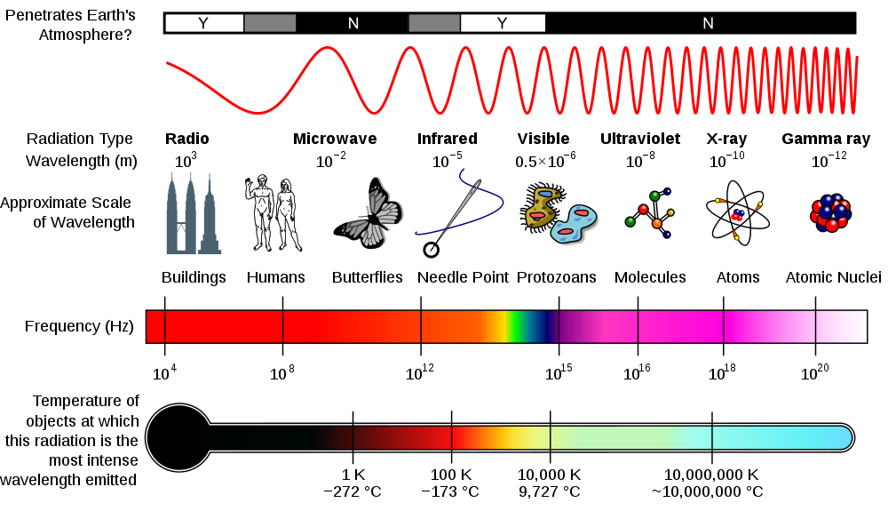

Closer look at the relationship between wavelength, frequency, and energy and appropriate units.

Summary of where we are at in understanding of atomic behavior

Then we take a 180:

Schrodinger’s Wave equation: areas of probability.

Orbitals

|  |  |  |  |  |  |
| --- | --- | --- | --- | --- | --- |
| Energy level (n) | Orbital | Shape | # of orbitals | # e‑ per orbital type | Total #e- |
| 1 | s |  |  |  |  |
| 2 | s  p |  |  |  |  |
| 3 | s  p  d |  |  |  |  |
| 4 | s  p  d  f |  |  |  |  |

Degenerate orbitals

Electron spin

Shell/subshell

Energy differences of shells/subshells

How electrons fill the orbitals *of a ground state atom*

* Aufbau principle: occupy lowest energy level possible
* Pauli exclusion principle: two electrons of same spin cannot occupy same orbital
* Hund’s rule: don’t share till you have to
* Aufbau exception: apparent violation of aufbau principle

Orbital notation for 2nd period elements to demonstrate the rules

Li Be B C

N O F Ne

Electron Configuration for 3rd period to show last rule:

Na: Mg: Al: Si:

P: S: Cl: Ar:

K: Ca: Sc: Ti:

Note on chromium, copper, and silver configuration (hybrid noble gas and orbital configuration)

Cr: [Ar]

Cu: [Ar]

Ag: [Kr]

Electronic configuration and recognizing Paramagnetic and Diamagnetic atoms

**Lesson 2: PES and validation of shell model of the atom**

Experiments that revealed the inside of atom

Thomson—cathode ray, revealed electron

Rutherford—gold foil, revealed the positive nucleus

Bohr (and others)—hydrogen line emission, revealed the organization of electrons

Schrodinger’s equation then mathematically theorized the organization of electrons, but did not experimentally prove it.

With amazing detectors, we have experimentally shown that molecules and atoms are affected by low energy ER, and then high energy ER can affect the displacement of electrons:

|  |  |
| --- | --- |
| **Radiation type** | **Aspects probed** |
| Microwave | Molecular rotation |
| IR | Molecular vibration |
| Visible | VE transitions |
| UV | VE transitions |
| x-ray | ICE transitions |

Photoelectron spectroscopy: bombard sample of atoms with specific amounts of energy, relate to number of electrons that are removed from the atom. (experimental validation of the shell model)









Energy calculations

Draw Bohr model of a ground state sodium atom. Think about the energy holding the electron in its orbital. Let’s say you wanted to remove an electron from the 3rd vs 1st energy level. The energy require to remove 1 electron is called ionization energy. We progress from VE to ICE and number them.

3rd energy level: 495 kJ/mol 1st energy level: 1.03 x 105 kJ/mol

Determine the wavelength of light that is needed in each instance.

**Lesson 3: Ion formation and electronic configuration**

What is an ion? How are they formed?

Collectively what groups lose electrons to form cations? Gain to form anions?

What is the goal in either gaining or losing valence electrons (main group)?

Compare the following orbital notation of nitrogen through aluminum atoms and ions

**Atoms**  **ions**

N:

O:

F:

Ne:

Na:

Mg:

Al:

Isoelectronic series:

What would be another example of an isoelectronic series?

What would not be considered an isoelectronic series:

Transition Metals and Ion formation

What orbital type do transition metals lose electrons from first? With that in mind, what charge do most transition metals have?

Multiple oxidation states of transition metals:

Sc:

Fe:

Special note on Zinc, Silver, Tin, Lead, and Bismuth

Transition metal ions and color (and evidence of aufbau exception)

Metallic character?????

Empty orbitals to draw from???

**Lesson 4: Periodic Trends**

Difference between a group and a period

Trends:

* Define
* Know direction of increase
* Explain the direction of increase
* Write an appropriate equation (if applicable) and relate to endothermic/exothermic

NOTE: stating the trend is NOT an explanation.

Ex: Q: why is fluorine more electronegative than oxygen

A: because electronegativity increases across a period. (NOT the right explanation)

Define the following trends, then give the direction of increase:

Atomic radii (size of atom)/ion size:

Ionization energy:

Electron affinity:

Electronegativity:

WHY??

Two factors determine these trends

Across a row:

Zeff (effective nuclear charge)

Down a group:

Distance of the VE from the nucleus

Writing equation for IE and EA

Interpreting successive IE data

(Usually only used on metals)

What group might this come from?

What type of ion would it form?

#ICE and VE?

Why do trends fall apart through the transition metals?

Classic Anomalies in trends and why

|  |  |  |
| --- | --- | --- |
| Periodic property | Anomalies | explanation |
| 1st IE |  |  |
| 1st IE |  |  |
| EA |  |  |

**Lesson 5: Misc on trends and anomalies**

Many periodic tables struggle with where to put hydrogen. Many place it above group 1 alkali metals, and some place above group 7 halogens.Explain the merits of both placements.

Going down group 14

metalloids

Ion formation and size implications

Ion size within an isoelectronic set

Explaining trends OR comparing two: must refer to both—or listed two factors

**Unit 1 Homework:**

|  |  |  |  |
| --- | --- | --- | --- |
| **year** | **Number** | **parts** | **comment** |
| 1999 | 2 | Omit 2b ii | 2b ii no longer tested |
| 2000 | 7 | a,b,c |  |
| 2002 | 6 | a, b |  |
| 2003B | 7 | All |  |
| 2005 | 7 | c, d |  |
| 2006b | 7 | a,c,d |  |
| 2006 | 8 | All (except e) |  |
| 2007b | 2 | All (part a no longer tested) | A: 90.5% Ne-20  9.5% Ne-22 |
| 2007b | 6 | All |  |
| 2008 | 5 | a-c |  |
| 2009 | 6 | a,b |  |
| 2009 | 3 | b,c |  |
| 2015 | 1 | e |  |